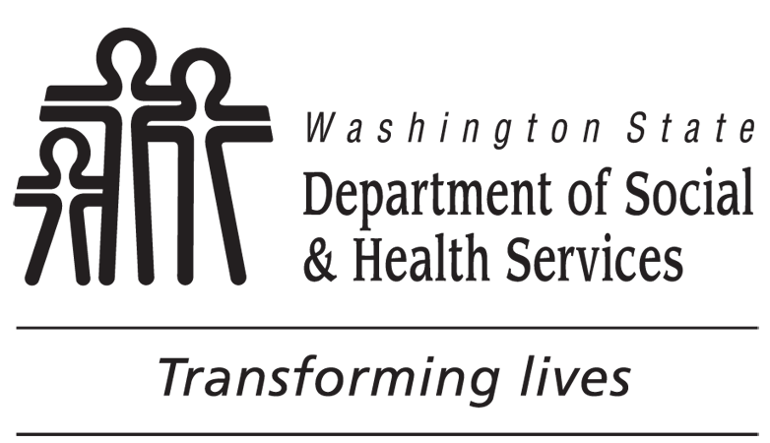 |  |  | Assisted Living Facility  Staff Sample / Record Review |  |  |  |  |  |  | Attachment K
 |  |  |  |  |  |  |  |  |  | ASSISTED LIVING FACILITY NAME
LICENSOR NAME |  |  |  |  |  |  |  |  |  | LICENSE NUMBER |  |  |  |  | INSPECTION DATE
Inspection Type: Initial Full Follow up Monitoring Complaint: Number
 | NAME AND TITLE |  |  | HIRE DATE | BIRTH DATE | SAFETY ORIENTA-TION AND FACILITY ORIENTA-TION | BACK-GROUND CHECK AND FINGER-PRINTING DATES | FIRST AID AND CPR | TRAINING EXEMPTION CNA, RN, ETC. |  | TB | FOOD CARD | BASIC 120 DAYS CERT EFFECTIVE 01/07/2012 | NURSE DELEGA-TION | SPECIALITY: DDA / MH / DEMENTIA / MANAGER | ADMIN QUALS AND TRAINING | CE – 12 HR PER BIRTHDAY YEAR EFFECTIVE 07/01/2012
1. |  | TITLE:
2. |  | TITLE:
3. |  | TITLE:
4. |  | TITLE:
5. |  | TITLE:
6. |  | TITLE:
7. |  | TITLE:
8. |  | TITLE:
9. |  | TITLE:
10. |  | TITLE:
Where applicable, RCS staff may place a check in the boxes to note the requirement is met. If issue or concern is identified, include all pertinent information such as date, results and/or other data to support the finding of non-compliance with regulation.

NOTES

Training Requirements for Assisted Living Facilities (ALF)

http://www.adsa.dshs.wa.gov/professional/training/afhalf/
Type of Training | ALF Administrator or Designee | ALF LTC Worker | Is DSHS Required to Approve Curriculum?
First Aid And CPR | Within 30 days of employment; maintain valid card. | Within 30 days of employment; maintain valid card. | NO
Orientation: Two (2) hours | Prior to providing care to a resident unless exempt from training. | Prior to providing care to a resident unless exempt from training. | YES
Safety Training: Three (3) hours | Prior to providing care to a resident unless exempt from training. | Prior to providing care to a resident unless exempt from training. | YES
70 hours of core basic and population specific training | Within 120 days of employment unless exempt from training. | Within 120 days of employment unless exempt from training. | YES
Continuing education | 12 hrs per year beginning 7/1/2012. CE must be completed by birthdate. | 12 hrs per year beginning 7/1/2012. CE must be completed by birthdate. | YES
Nurse Delegation Core and Diabetes | Must be a Nursing Assistant Registered, Nursing Assistant Certified, or Certified Home Care Aide and complete ND core training before accepting a delegated task. | Must be a Nursing Assistant Registered, Nursing Assistant Certified, or Certified Home Care Aide and complete ND core training before accepting a delegated task. | YES  Must use DSHS curriculum. Instructors must be DSHS contracted community instructors.
Specialty Training | If an ALF serves one or more residents with special needs, the administrator or designee must complete manager specialty training and demonstrate competency by passing the DSHS test.  If a resident develops special needs while living in an ALF without a specialty designation, the administrator or designee have 120 days to complete manager specialty training and demonstrate competency. | If an ALF serves one or more residents with special needs, all LTC workers must receive training regarding the specialty needs of individual residents in the facility.  DSHS approved curriculum must be used and the LTC workers must pass the DSHS test. | YES  Instructors must be DSHS contracted community instructors to provide manager specialty training.
Exemptions: RN, LPN, CNA, LTC worker initially hired prior to 01/07/2012 who completed all training requirements in effect at that time.
See RCW 18.88B.041.

